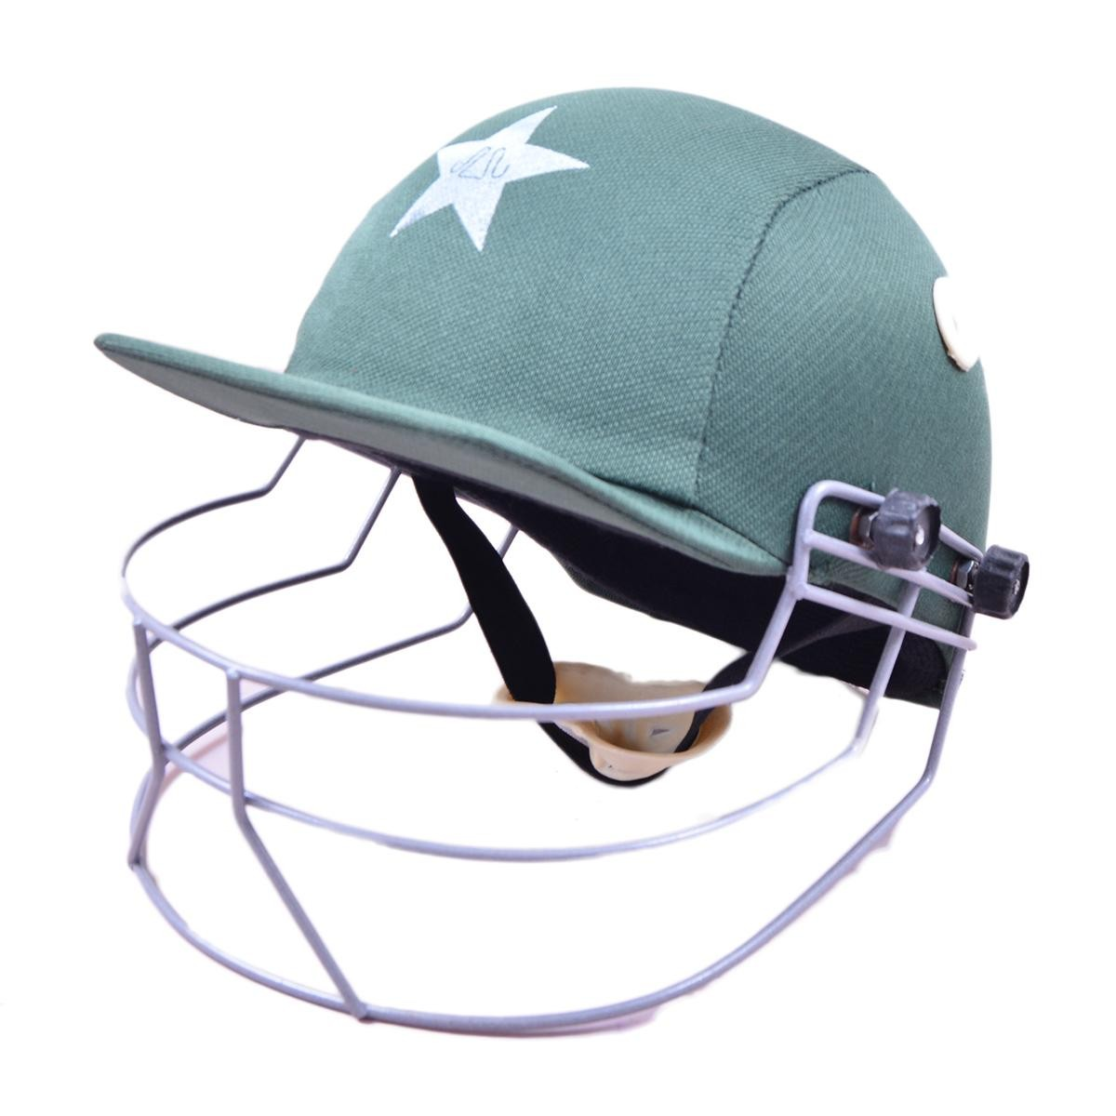

Cricket Helmet For Kids

* Cricket Helmet For Kids (For Children Under 14 Years, Good Quality)